Applied Data Science Capstone
Segmenting and Clustering Neighborhoods in Leuven, Belgium
Author: Daniel García

Problem Description.
Derived from a job offer that I currently have, I decided to take as a project my current situation. The job offer is to work in another city, and in fact in another country. Which brings me to have to find out where living in the city, i.e., analyze that neighborhood or area of the city, we should live or is best place for us according to our criteria.
The city is Leuven in Belgium. Leuven is a city located to the East of Brussels (Belgium), known for its breweries. In a central square Hall, from the 15th century, is its high needle. The building is decorated with hundreds of statues of Saints, biblical and local characters. Opposite, the Gothic church of St. Peter has a picture of the last supper of the Flemish primitive painter Dirk Bouts. Nearby is Oude Markt, a long square full of bars and cafes.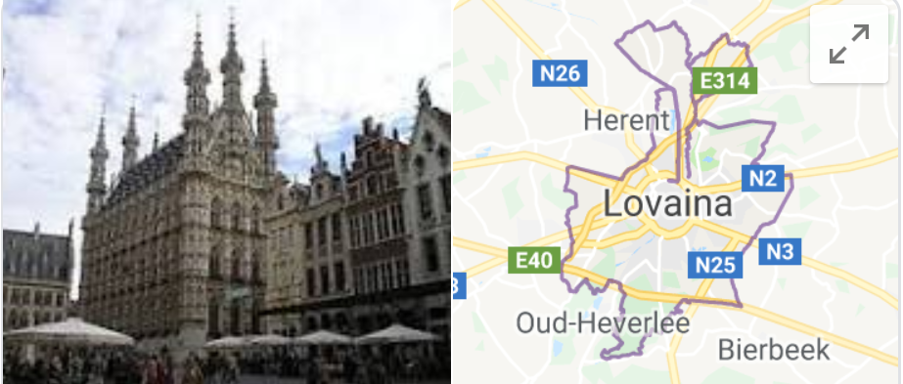
The intention is to apply the model of segmentation of the districts of Leuven to analyze and detreminar which could be a good choice to live, based on existing sites around each neighborhood.

